Google Cloud Build Secret Scan
Integrate AccuKnox secret scanning into Google Cloud Build to catch leaked credentials, API keys, and tokens before they reach the wrong hands. The pipeline uses the AccuKnox ASPM Scanner CLI with TruffleHog, runs in three steps, and uploads findings directly to your AccuKnox CSPM panel.

Prerequisites
• GCP project with Cloud Build enabled
• AccuKnox SaaS access with permission to generate tokens
• A git repository connected to Cloud Build
• A Cloud Build trigger pointing at the repository you want to scan

Steps for integration

Step 1: Generate an AccuKnox token
Log in to AccuKnox SaaS. Navigate to Settings, then Tokens and create a new token.
##Screenshot
Save these three values for use in Step 3:
Field | Where to find it
Endpoint | Your AccuKnox CSPM URL, for example, cspm.demo.accuknox.com
Token | The token string shown after creation
Label | Any descriptive string you choose

Step 2: Add the cloudbuild.yaml to your repository
Drop the following file at the root of your repository as cloudbuild.yaml. The AccuKnox credentials come from the Cloud Build trigger config (Step 3). The secret-specific values (soft-fail, history depth, scan path) are edited directly in step 3 of the YAML.
# =============================================================================
# AccuKnox Secret Scan (TruffleHog) — Google Cloud Build Pipeline
# =============================================================================

steps:

# ---------------------------------------------------------------------------
# Step 1: Validate required AccuKnox inputs (fail fast)
# ---------------------------------------------------------------------------
- id: validate-inputs
name: ubuntu:24.04
entrypoint: bash
env:
- ACCUKNOX_ENDPOINT=${_ACCUKNOX_ENDPOINT}
- ACCUKNOX_TOKEN=${_ACCUKNOX_TOKEN}
- ACCUKNOX_LABEL=${_ACCUKNOX_LABEL}
args:
- -c
- |
set -e
echo "Validating required inputs..."
if [ -z "$$ACCUKNOX_ENDPOINT" ] || [ -z "$$ACCUKNOX_TOKEN" ] || [ -z "$$ACCUKNOX_LABEL" ]; then
echo "ERROR: _ACCUKNOX_ENDPOINT, _ACCUKNOX_TOKEN, and _ACCUKNOX_LABEL must be set!"
exit 1
fi
echo "All required inputs present."

# ---------------------------------------------------------------------------
# Step 2: Download the AccuKnox ASPM Scanner CLI
# ---------------------------------------------------------------------------
- id: download-scanner
name: ubuntu:24.04
entrypoint: bash
args:
- -c
- |
set -e
export DEBIAN_FRONTEND=noninteractive
apt-get update -qq
apt-get install -y -qq --no-install-recommends curl ca-certificates

echo "Downloading AccuKnox ASPM Scanner v0.14.2..."
curl -sSL https://github.com/accuknox/aspm-scanner-cli/releases/download/v0.14.2/accuknox-aspm-scanner \
-o /workspace/accuknox-aspm-scanner
chmod +x /workspace/accuknox-aspm-scanner
echo "Scanner downloaded to /workspace/accuknox-aspm-scanner"

# ---------------------------------------------------------------------------
# Step 3: Install TruffleHog, run the secret scan, upload to AccuKnox CSPM
# ---------------------------------------------------------------------------
- id: run-secret-scan
name: ubuntu:24.04
entrypoint: bash
env:
- ACCUKNOX_ENDPOINT=${_ACCUKNOX_ENDPOINT}
- ACCUKNOX_TOKEN=${_ACCUKNOX_TOKEN}
- ACCUKNOX_LABEL=${_ACCUKNOX_LABEL}
args:
- -c
- |
set -e

# ====================================================================
# Secret-specific configuration — edit these values as needed
# ====================================================================
SOFT_FAIL="true" # true to keep pipeline green on findings
UNSHALLOW_HISTORY="true" # true to scan full git history (slower)
SCAN_PATH="." # path within /workspace to scan
# ====================================================================

# Install ca-certificates (HTTPS upload) and git (required by TruffleHog)
export DEBIAN_FRONTEND=noninteractive
apt-get update -qq
apt-get install -y -qq --no-install-recommends ca-certificates git

# Optionally fetch full git history for deeper scanning
if [ "$$UNSHALLOW_HISTORY" = "true" ]; then
echo "Fetching full git history..."
cd /workspace
git fetch --unshallow || echo "Repo is already unshallow or unshallow failed; continuing."
fi

# Install the secret-scanning tool (TruffleHog) locally
# Required because we are not using --container-mode
echo "Installing secret scanning tool (TruffleHog)..."
/workspace/accuknox-aspm-scanner tool install --type secret

# Resolve soft-fail flag
SOFT_FAIL=$(echo "$$SOFT_FAIL" | tr -d ' \t\r\n')
SOFT_FAIL_ARG=""
if [ "$$SOFT_FAIL" = "true" ]; then
SOFT_FAIL_ARG="--softfail"
fi

# Run the secret scan
echo "Running AccuKnox secret scan on $$SCAN_PATH ..."
cd /workspace
/workspace/accuknox-aspm-scanner scan --keep-results $$SOFT_FAIL_ARG secret \
--command "git file://$$SCAN_PATH"

# =============================================================================
# Substitutions (only AccuKnox credentials — set these in the trigger UI)
# _ACCUKNOX_ENDPOINT -> accuknox_endpoint (required)
# _ACCUKNOX_TOKEN -> accuknox_token (required)
# _ACCUKNOX_LABEL -> accuknox_label (required, e.g. "secret-myrepo")
# =============================================================================
substitutions:
_ACCUKNOX_ENDPOINT: ""
_ACCUKNOX_TOKEN: ""
_ACCUKNOX_LABEL: ""

options:
logging: CLOUD_LOGGING_ONLY
machineType: E2_HIGHCPU_8

timeout: 1800s

Before committing, edit the secret-specific block in step 3 of the YAML to match your needs:
Variable | What to set
SOFT_FAIL | true to keep the pipeline green on findings, false to fail the build
UNSHALLOW_HISTORY | true to scan the full git history (catches secrets in old commits), false to scan only the latest commit (faster)
SCAN_PATH | Path within /workspace to scan. Default . scans the entire repo.

Commit and push the file to your repository.

Step 3: Configure the Cloud Build trigger
Open Cloud Build in the GCP console. Create or edit a trigger pointing at your repository.
Under Configuration, select Cloud Build configuration file and point it at cloudbuild.yaml.
Under Advanced, then Substitution variables, add the three AccuKnox credentials:
Variable name | Value
_ACCUKNOX_ENDPOINT | Your CSPM endpoint, for example, cspm.demo.accuknox.com
_ACCUKNOX_TOKEN | The token from Step 1
_ACCUKNOX_LABEL | A label of your choice, for example, secret-myrepo

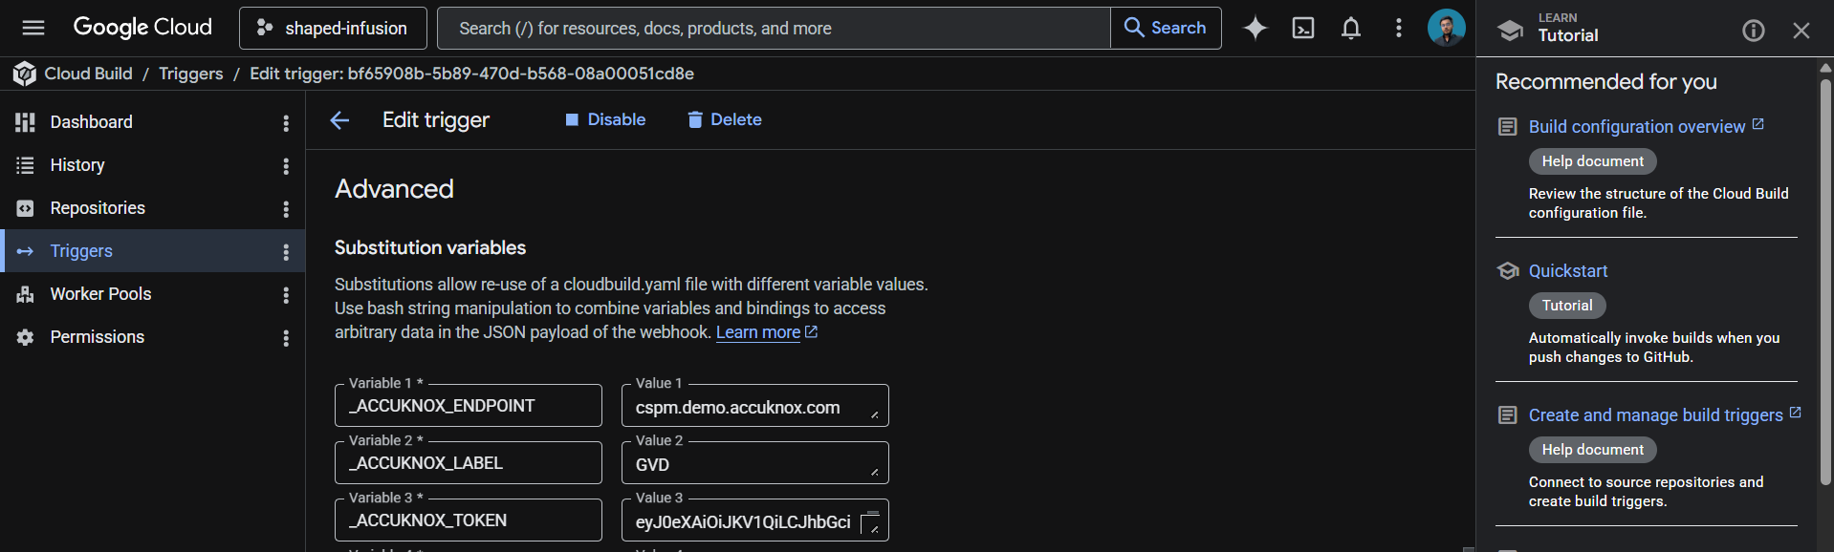
These values live in the trigger config rather than the YAML, which keeps your token out of git history.
Save the trigger. The next push to the watched branch runs the pipeline.

How the pipeline works
Step | Purpose
1. validate-inputs | Fails the build in under a second if any AccuKnox credential is missing. Saves a wasted scanner download.
2. download-scanner | Fetches the AccuKnox ASPM Scanner v0.14.2 binary into /workspace, which persists across Cloud Build steps.
3. run-secret-scan | Installs git and TruffleHog, fetches the full git history if requested, runs the scan, and uploads findings to AccuKnox CSPM.

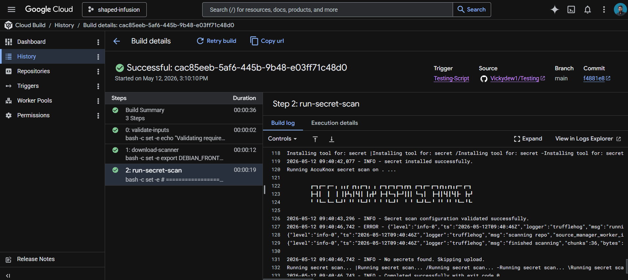

Shallow vs full history
Cloud Build clones repositories at depth 1 by default, meaning only the latest commit is available. TruffleHog can only scan what it can see, so this is a real tradeoff:
Setting | Tradeoff
UNSHALLOW_HISTORY="false" | Scans only HEAD. Fast (seconds). Catches new secrets as they land. Misses anything committed before the build was triggered.
UNSHALLOW_HISTORY="true" | Scans the full git history. Slower (varies by repo age). Catches old leaked credentials, including ones since deleted from current files.

Recommended approach: run a one-time full-history scan when first onboarding the repo to flush out historical leaks, then switch to shallow scanning for ongoing CI. New secrets get caught at commit time, which is the high-value case.

Viewing results
Open the AccuKnox CSPM panel. Filter findings by the label you set in _ACCUKNOX_LABEL. Each finding includes the detector type (AWS, GitHub, Slack, etc.), the file and line where the secret was found, the commit and author who introduced it, and a verification status that tells you whether the credential is still live.

Before the AccuKnox scan
Without secret scanning, hardcoded credentials slip through code review, get pushed to public or private repositories, and sit there until someone notices, or until an attacker does. Even private repos leak through misconfigured forks, cloned developer laptops, and CI logs. The longer a secret stays committed, the more places it propagates.

After AccuKnox scan integration
Once the pipeline above is wired up, every push triggers a TruffleHog scan. Detected secrets surface in your AccuKnox CSPM panel with verification status and full commit context, so security teams know what to rotate, where it leaked from, and how recently. Critical findings can fail the build by setting SOFT_FAIL to false in step 3 of the YAML.


